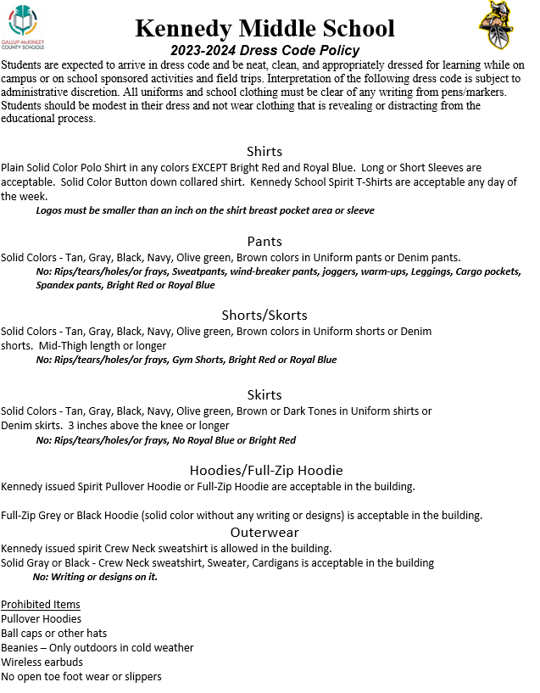

PROHIBITED: ITEMS NOT ALLOWED
Accessories including, but not limited to, studded bracelets, belts, or necklaces; belt loop or chain wallets, chains that connect body piercing and belts that extend more than 6 inches beyond the buckle or that hang down. Pins, clothing, tattoos, or accessories that advertise, display, or promote any drug (including tobacco and alcohol), sexual innuendo, violence, weaponry, disruptive symbols, profanity, hate or bigotry towards any group or is offensive, disrespectful to other individuals. Safety pins, straight pins, paperclips or similar objects used as decoration or accessories on any type of attire. These objects may be considered weapons. No key chains or any other item hanging out of clothing. Baseball caps are not allowed at school. Logos that can be affiliated with gang activity (ex. ICP, South Pole, etc.), criminal activity, violence, drugs or alcohol, or guns will not be allowed at school on any item (clothing, backpacks, jewelry, etc.). Bandanas of any color are not allowed.

DRESS CODE VIOLATIONS
Parents of students who violate the dress code policy will be contacted and student will be sent home to change or bring in a change of clothing. If parents cannot be reached, student will serve In School Suspension for the day with the teacher on duty. Students will not be allowed to participate in SPIRIT DAY if they violate dress code for that week. Continued violations will be charged as misbehaviors, and administration will follow board policy.

DISCLAIMER
Kennedy Mid School Administration will make the final determination if there is a question about a student violating the dress code policy. Any gifts given to students will follow the same dress code policy.

